**ARYAMAN MISHRA**

**19BCE1027**

clear all

syms x c_0 c_1 c_2 c_3 c_4 c_5 c_6

p1x=input('Coefficient of D2y :')

p2x=input('Coefficient of Dy :')

p3x=input('Coefficient of y :')

c=[c_0, c_1, c_2, c_3, c_4, c_5, c_6]

y=sum(c.*(x).^(0:6))

dy=diff(y)

d2y=diff(dy)

ode=p1x*d2y+p2x*dy+p3x*y %substitution has been done automatically

ps=collect(ode,x)

d=coeffs(ps,x)

[c_2,c_3,c_4,c_5,c_6]=solve(d(1),d(2),d(3),d(4),d(5),{c_2,c_3,c_4,c_5,c_6})

z=subs(y)

disp('The general solution of the given ode around x=0 is given by:')

disp(z)

i1=input('Enter y(0) :')

i2=input('Enter Dy(0):')

zz=subs(z,[c_0,c_1],[i1,i2])

disp(' The Particular solution of the given ode around x=0 is given by:')

disp(zz)

ezplot(zz,[-4 4])

1. 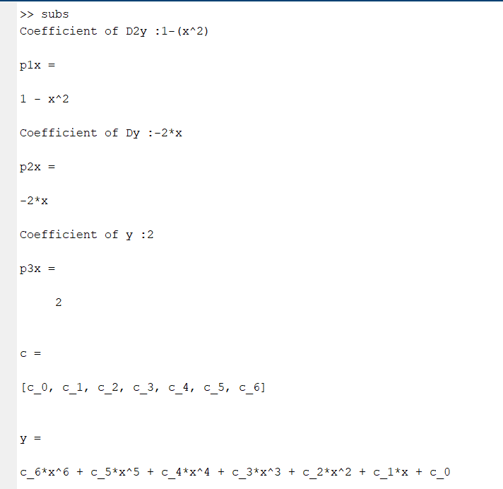

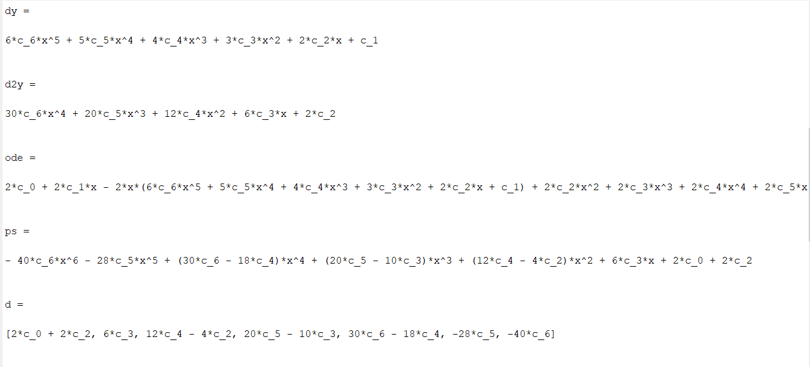

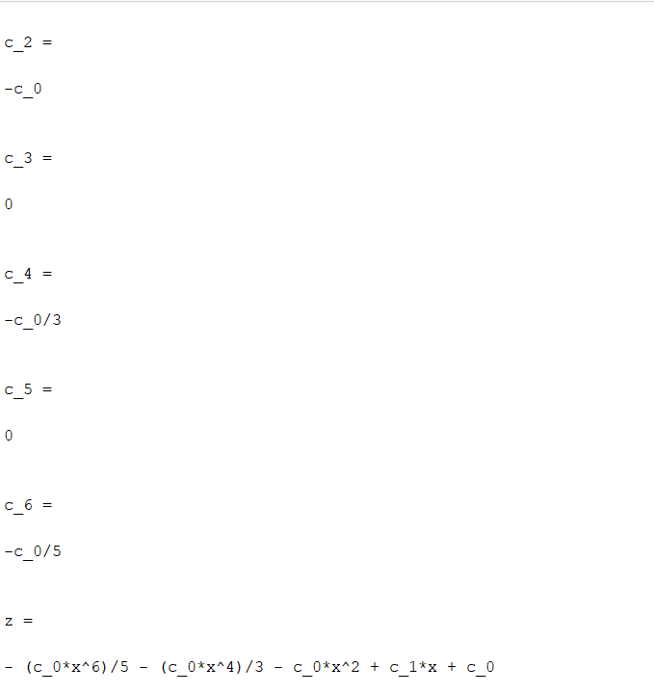

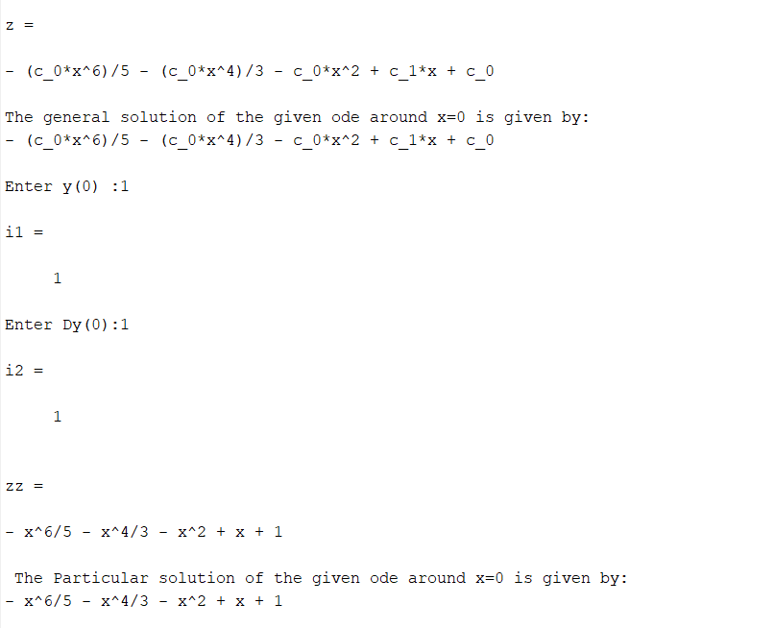

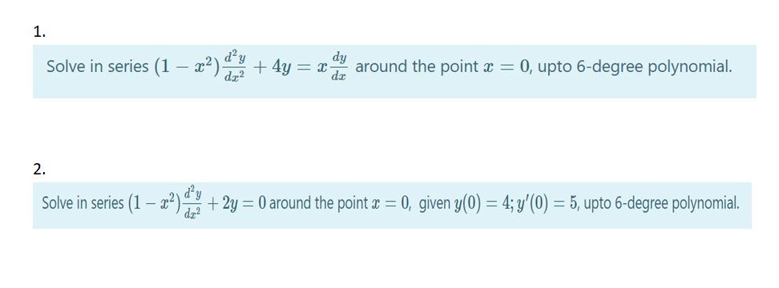

1)

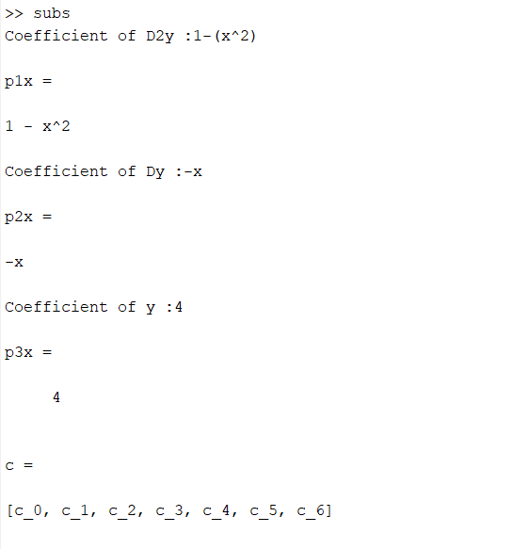

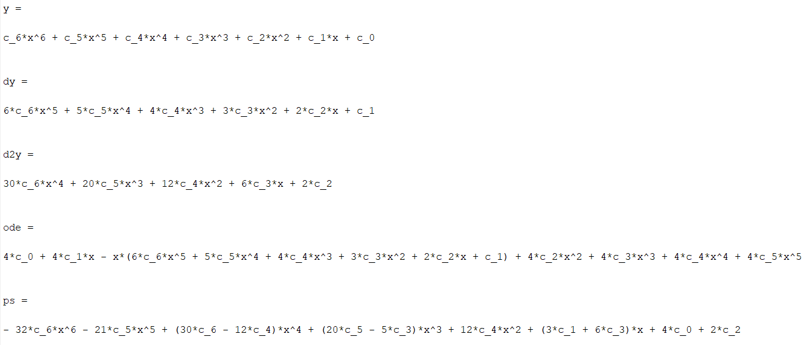

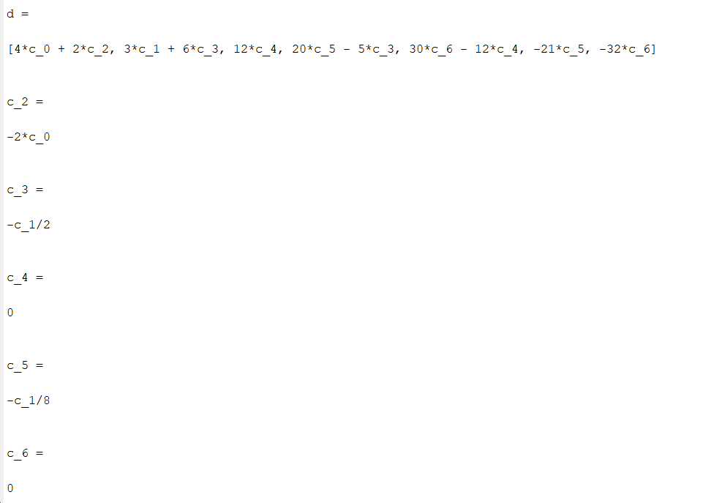

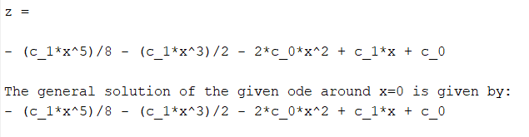

2)

